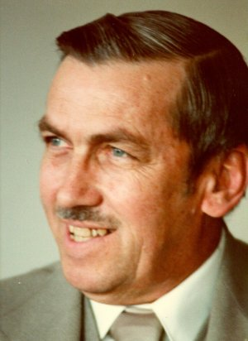
Leslie Walter Trowbridge, 91 of Greeley died Friday, Feb 3, 2012. He was born May 21, 1920 and grew up on a dairy farm in Milladore, Wisconsin. After serving in the U.S. Army Air Force as a meteorologist in China and India during World War II, he returned from service and married Dorothee Kohring of Chicago in 1946. He began his career as a science teacher and earned a PhD in Science Education from the University of Michigan. Dr. Trowbridge served as Chairman of the Science Education Department at the University of Northern Colorado from 1965 to 1983. He served as President of the National Science Teachers Association from 1973-74.

Dr. Trowbridge was the author of sixteen books on elementary science, teaching secondary school science, and meteorology, which were used by more than two million students in schools in the United States.

He is survived by his wife, Dorothee; three sons, David, Thomas, and Howard; a daughter Edith; nine grandchildren and three great grandchildren. He is pre-deceased by his parents and two brothers, Robert and Charles.

Leslie had a deep passion for teaching and a lifelong devotion to science education. He instilled a love of science in his children and played a key role in an international movement that championed inquiry-based science learning. He trained many students who are influential in science education around the world.

In recognition of his life work, a fund devoted to science teaching and learning will be established at the University of Northern Colorado. Gifts in memory of Leslie Trowbridge may be directed to the UNC Foundation, Campus Box 20, Greeley, CO 80639.

A memorial service will be held at the United First Methodist Church, 917 10th Avenue, Greeley on Sunday, March 11, 2012 from 1:00 – 3:00 pm. Family and friends may view the online obituary and send condolences at www.allnutt.com.

